**BCSC 4126 SIMULATION & MODELING**

**ASSIGNMENT ONE (1)**

**Group Members:**1. George Jesse- BCSC01/0034/2021

2. Johnson Kanyi – BCSC01/0019/2021

3. Sila Otieno- BCSC01/0049/2021

4. Beth Anjela- BCSC01/0037/2021

5. Bilha Litunya- BCSC01/0038/2021

**Questions**

**a) Explain why random sampling is necessary in simulation experiments (4 marks) \.**

1. ***For Variability***

Random sampling enables variability reduction ensuring variations within data are appropriately captured. Many systems inherit this for example patient arrival times and service durations.

1. ***Facilitates Statistical Analysis and Inferences***

By using random samples, it is possible to apply statistical techniques for analysis allowing researchers to draw valid and reliable inferences about a population or system leading to more reliable conclusions.

1. ***Unbiased Representation***

It allows a fair selection across different possible outcomes ensuring that the simulation results are unbiased leading to more reliable and generalized results.

1. ***Enables the ‘What If’ Analysis***

With random variables, a simulation can test different scenarios and conditions by altering random variables thus helping to understand a system’s behaviour under varied inputs

**b) Dr. Mkubwa is a dentist who schedules all her patients for 30-minutes appointments. Some of the patients take more or less than 30 minutes depending on the type of dental work to be done. The following summary shows the various categories of work, their probabilities and the time actually needed to complete the work.**

|  |  |  |
| --- | --- | --- |
| **Category** | **Time Required** | **Probability** |
| Filling | 45 min | 0.40 |
| Crown | 60 min | 0.15 |
| Cleaning | 15 min | 0.15 |
| Extraction | 45 min | 0.10 |
| Check Up | 15 min | 0.20 |

**Simulate the dentist’s clinic for four hours and determine average waiting time for the patients as well as the idleness of the doctor. Assume that all the patients show up at the clinic at exactly their scheduled arrival time starting at 10 a.m. Use the following random numbers for handling the above problem: 40, 82, 11, 34, 25, 66, 17, 79 (6 marks)**

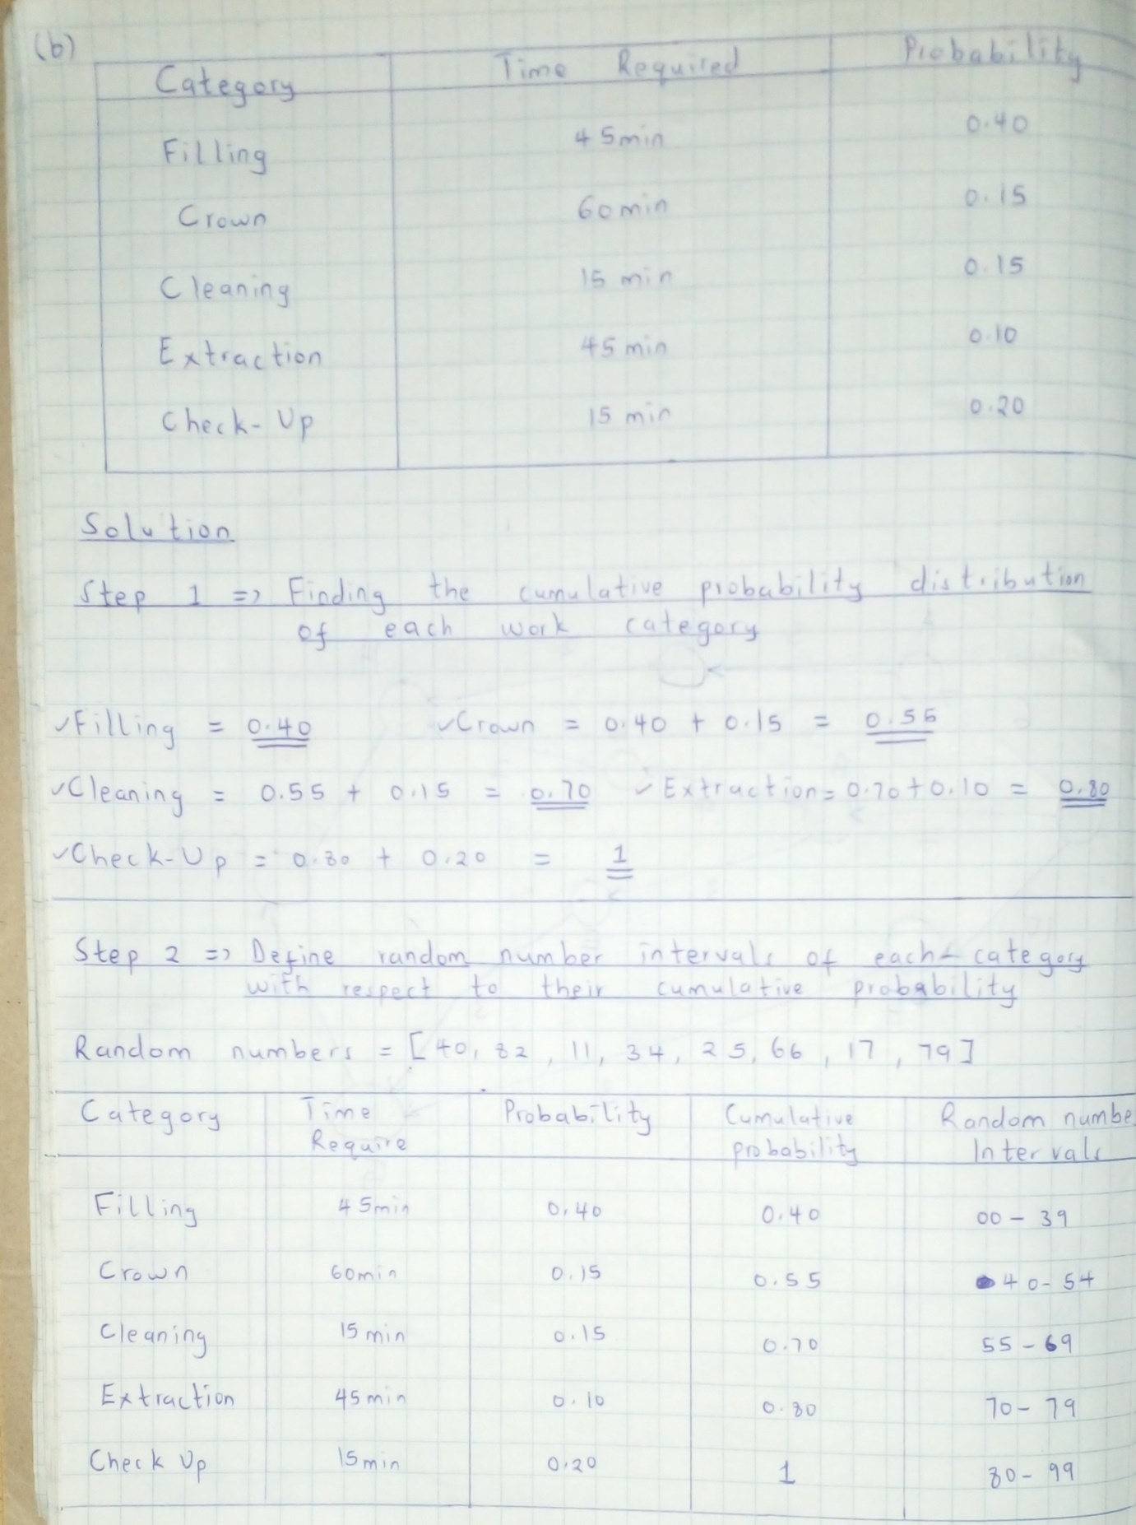

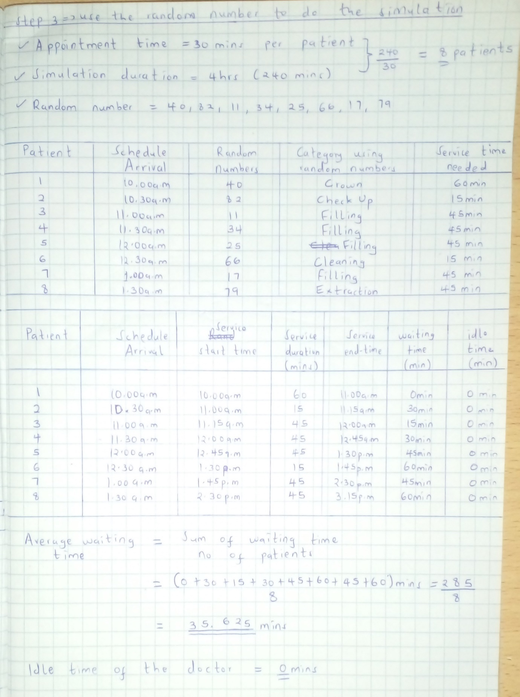

**c) Consider a simple server queuing system that starts at time t=0. The arrivals occur at times 1.2, 1.8, 2.6, 3.8, 6.0, 6.2, 7.0, 7.5, 8.6, and 0.2. Departures occur at times 3.0, 4.2, 4.9, 5.6 and 10. Time is in minutes. Simulate this Queuing System until when the sixth client enters service and estimate: (10 marks)**

**i. The average delay in the waiting line**

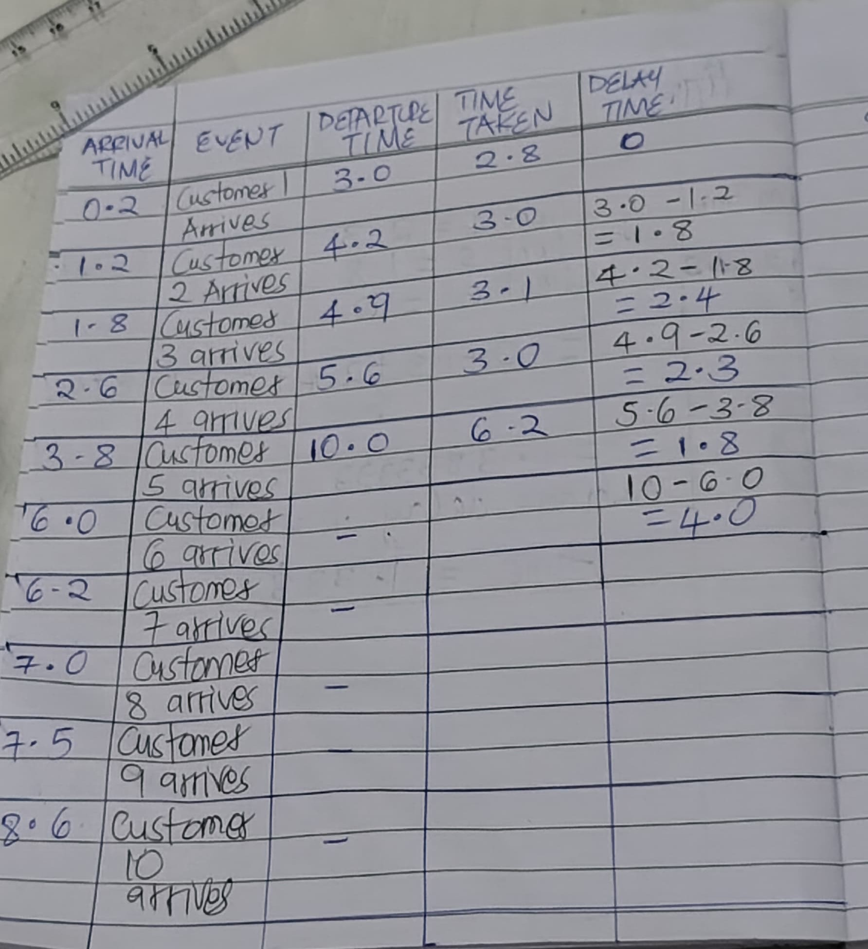

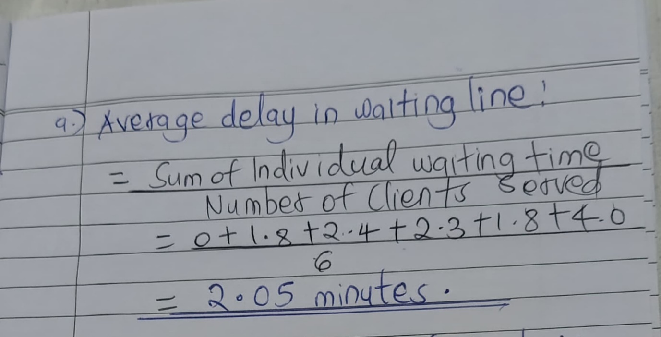

**ii. The average number of clients in the waiting line at any time**

**iii. The server utilization rate**The solution for questions ii and iii are as attached in the below image:

